Craete new pipline project and add this pipline

pipeline {

agent any

environment{

EMAIL_TO="your email id"

}

stages {

stage('Test') {

steps {

echo 'Testing an Email'

}

}

}

post{

failure{

emailext(

to:"${EMAIL_TO}",

subject: "Build Failed: ${env.JOB_NAME} #${env.BUILD_NUMBER}",

body:"Please check and build logs at ${env.BUILD_URL}"

)

}

}

}

Save and apply

Step:2

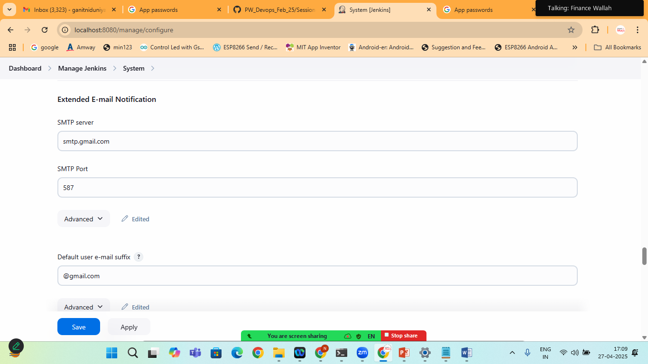

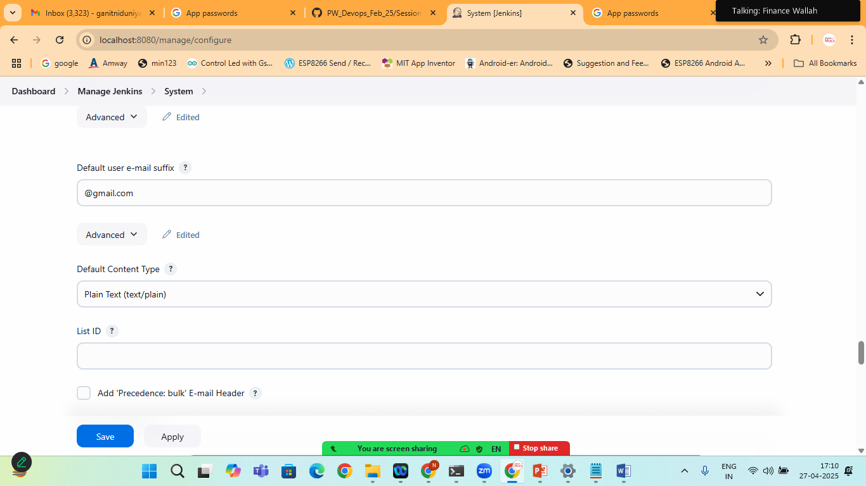

Click on save and apply

And build the project

Once the build will success

Try changing the pipeline syntax:

pipeline {

agent any

environment{

EMAIL_TO="your_email_id@gmail.com"

}

stages {

stage('Test') {

steps {

echo 'Testing an Email'

}

}

stage('mvn') {

steps {

sh ''' mvn clean install '''

}

}

}

post{

failure{

emailext(

to:"${EMAIL_TO}",

subject: "Build Failed: ${env.JOB_NAME} #${env.BUILD_NUMBER}",

body:"Please check and build logs at ${env.BUILD_URL}"

)

}

}

}

Now save and apply

Build the project

It will send an failure email to you gmail account